## Lesson 6 – Activity Sheet

## Getting Started

* Mount a felt tip pen or crayon on the pen holder
* Test it draws a line by driving the motor forward or reverse to create a line

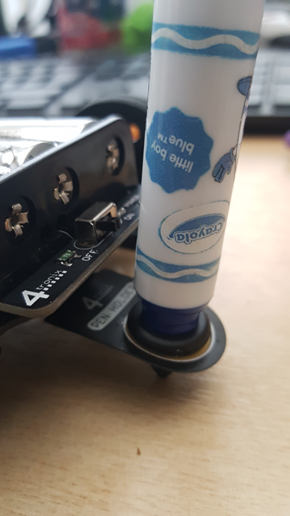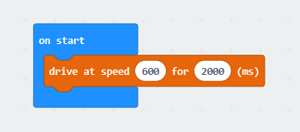

## Success Criteria

* Apply your understanding of motor outputs
* Develop your understanding of **iteration** (**loop**ing) using **conditional** and **count controlled** loops
* Be able to plan and drawn shapes using iteration

Create a plan for the following shapes and test the blocks as per the example

|  |  |  |
| --- | --- | --- |
| **Shape** | **Plan** | **Blocks** |
| Square | Repeat 4  Drive at 600 for half a second  Spin Left at 600 for 200ms |  |
| Triangle |  |  |
| Regular **Polygon** (eg Octagon) |  |  |
| Circle |  |  |

## Pro-tip

* There is no correct answer here as it is dependent on floor material and battery charge though a speed of 600 for 400ms in the previous demo did a 180 turn on a tiled floor. A speed of 600 and turn of 200ms is about 90deg and 600 @100ms is about 45 degrees. This works out at roughly 2.2ms per degree, but this is very battery and floor material dependent

## Test Time

* Think Pair Share your ideas
* Swap worksheets with a partner and test their algorithms
* What happens if you increase the speed?
* How could you move the robot without drawing? Would a delay help?

## Stretch Tasks

|  |  |  |
| --- | --- | --- |
| **Shape** | **Plan** | **Blocks** |
| House |  |  |
| Your Initials |  |  |
| Multi-Coloured Shape |  |  |

## Final Thoughts

* During this lesson we have looked at the iteration construct to create count controlled and conditional loops
* We have identified why it is better to use iteration than sequence when repeating sections of code
* We have used these techniques with the Bit:Bot to create a line drawing, identifying the power and turn times needed to produce angles